**Humm closes, but tech lives on**

**By**[**Aimee Glossop**](https://startupnews.com.au/author/aimee-glossop/) **3 March 2022**

[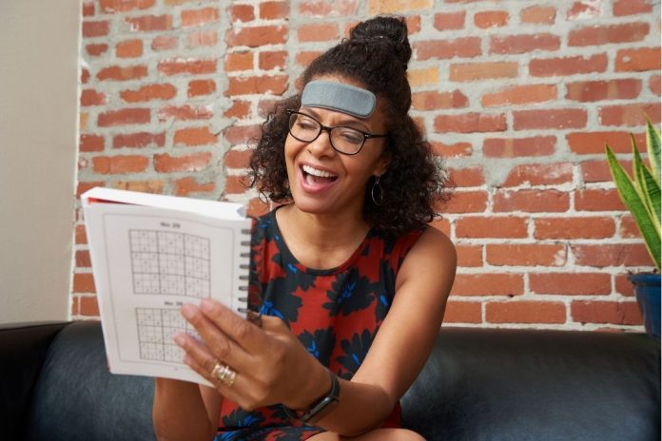](https://startupnews.com.au/wp-content/uploads/2022/03/humm-closing-down.jpg)Humm, the creator of a wearable technology designed to enhance brain performance, has announced it is shutting down its operations after falling short in its Series A funding round. Image – Humm  
Five years since its inception in Perth, wearable tech startup **Humm**has announced it is closing the curtains on its startup journey after falling short of its funding requirements.  
CEO and Co-founder **Iain McIntyre** took to his personal LinkedIn and Humm’s YouTube channel last week to share the unfortunate news with supporters of the innovative technology company.  
The news isn’t all sad however, with Iain explaining the advancements in technology made at Humm will go on to assist Californian startup **Rogalife** in creating a wearable device targeted to alleviate anxiety.  
Innovative technology embraced by Silicon Valley  
Co-founded by four uni friends from Perth, Humm graduated from an early cohort of the Plus Eight tech accelerator.

The tech startup began with a mission – to empower people to live better lives by harnessing emerging technologies and new discoveries in neuroscience.

In 2018, Humm was accepted into and joined the UC Berkeley SkyDeck Accelerator in California, aimed at providing global startups with the support needed to gain investment. The Humm team embraced the opportunity and [relocated to San Francisco](https://startupnews.com.au/2018/06/03/humm-tech-move-to-silicon-valley/), working hard to raise an impressive [$2.6 million](https://startupnews.com.au/2020/01/08/humm-raises-a3-7m/)in seed funding by the end of 2019.  
By 2020, Humm’s fundraising efforts culminated in the creation of the company’s first product – the Humm patch.

A prototype of the Humm patch. Image – Humm

“It’s a wearable patch that sticks on your forehead that uses some of the latest neuroscience research into the field of neurostimulation to improve your memory,” Mr McIntyre explained via the video posted to Humm’s YouTube.

The Humm patch was designed as a reusable but disposable device, intended to be used approximately 10 times for sessions of 90 minutes, in times when improved brain performance was desired.

“At that time we had been prototyping and testing and had run some trials internally and externally using this patch to improve people’s working memory, and we had seen really good results against placebo,” he said.

Trials and tribulations of launching a startup in a post-Covid world

However, not unlike many businesses, Humm hit insurmountable roadblocks in the onslaught of Covid-19.  
“Unfortunately in 2020 things became really difficult when Covid made the global hardware market an incredibly tricky place to navigate.  
“As a result, not only did we have to go through all of the normal trials and tribulations at Humm of prototyping a novel device and testing it in a scientific and customer context to see if people wanted to pay for it, but also we had to deal with a constant reshuffle of our supply chain as we sought to find the right build that we could actually manufacture this at scale,” said Mr McIntyre.  
Alongside these issues Humm then had to contend with were severe shipping delays, and the decline in data feedback speed that came with testing a prototype remotely.  
**We did manage to conquer those things and in about April 2021 we were ready to proceed, however at that time we had realised that the regulatory side of this was going to be perhaps a little bit more difficult to navigate.**A person in a red suit
Iain McIntyre, Humm CEO

“There was a lack of clarity in the existing regulatory framework set out by the FDA about whether this device is considered a medical device or not.”  
Attempting to overcome this issue, Humm implement a six-month at home trial of 75 participants, finding 50% experienced a significant improvement in their memory and 25% were willing to pay for the device.  
“That’s pretty good in a prototype context setting for an early stage company with such a novel piece of technology and I think that indicates that there’s a future for this technology,” he said.  
Despite these favourable trial results, the tech startup fell short in its Series A funding round and has made the difficult decision to halt its operations.  
“Unfortunately we weren’t able to get it to the point that we wanted to from an investment perspective to be able to convince investors to enable us to fund this to mass production.  
“We just didn’t raise anywhere near enough money to make that happen and unfortunately during Covid it was just too hard to make progress fast enough to get to that point,” Mr McIntyre explained.  
Humm technology to support Rogalife in mission to relieve anxiety  
While this may be the end of the line for Humm, the company’s efforts in advancing wearable technology will not go to waste as Mr McIntyre joins the team at Californian tech startup Rogalife, lead by entrepreneur **Ami Lebendiker**.  
“Ami suggested that I joined him at his team and that I bring along all of the work that I had done at Humm and that the team had done and added to what they were doing in the future,” said Mr McIntyre.

Rogalife shares a similar vision to Humm, with a goal to produce a wearable technology that use electrical stimulation to alleviate anxiety.

**It’s not often you meet people who have the same vision for the technology that you do  
where we both envisioned that this technology could be something that changes the daily lives of millions if not billions of people in the future by altering the electricity of the brain and the nervous system.**

*Iain McIntyre, Humm CEO*

Mr McIntyre remains optimistic for the future of the technology, having experienced his own struggles with anxiety during Humm’s downfall, and finding relief using the Rogalife device.

“It’s very sad for me to leave the journey but I am really proud of what we’ve done, I’m proud of everyone who supported us and helped us and I just want to say thank you,” he said.

While the Humm may have fallen silent for now, hope still rings out for a future in which wearable technology can empower people to live to the fullest. Humm’s part of that journey.